Name:Bomma Naveen
Reg No:192373056
Course code:CSA0924

- Read the basic salary of an employee. Calculate HRA as 20%, DA as 15%, and gross salary; add a bonus of 5% when basic salary exceeds 50000.
- FlowChart:

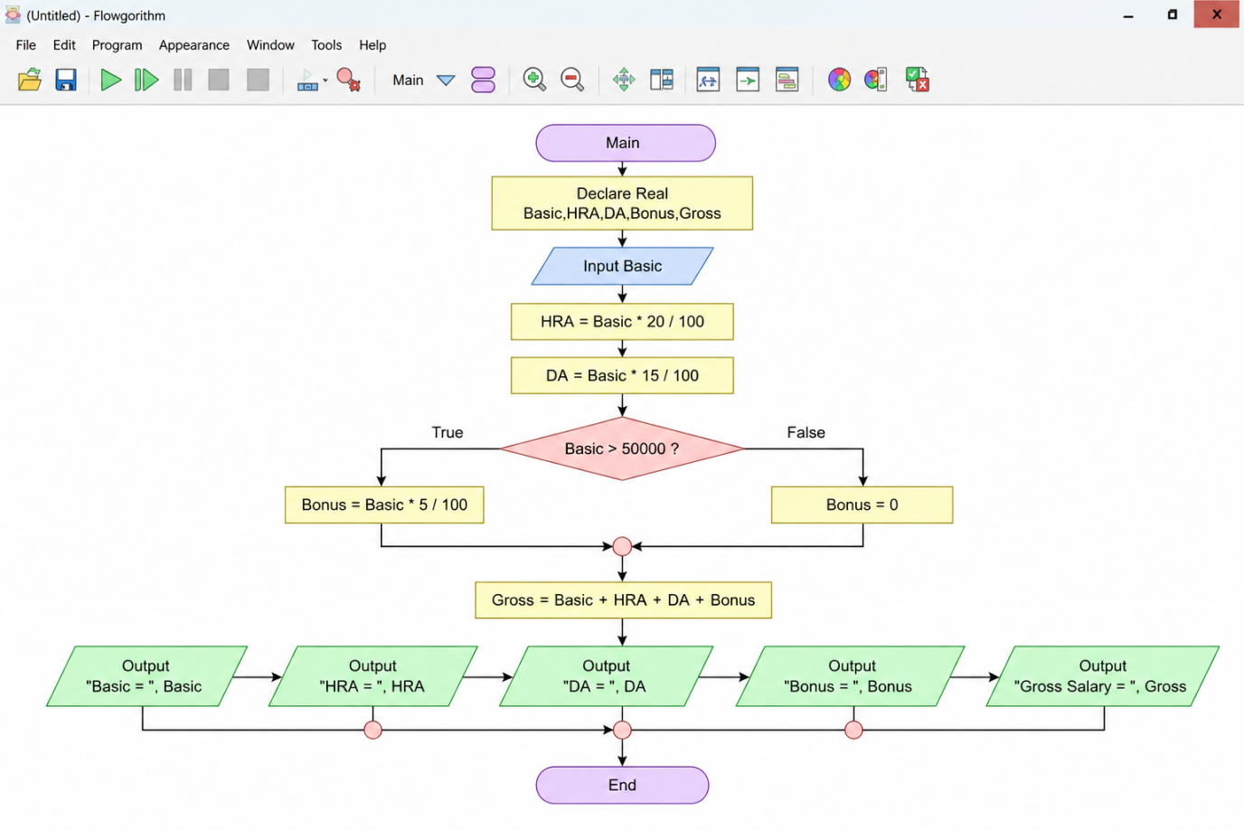
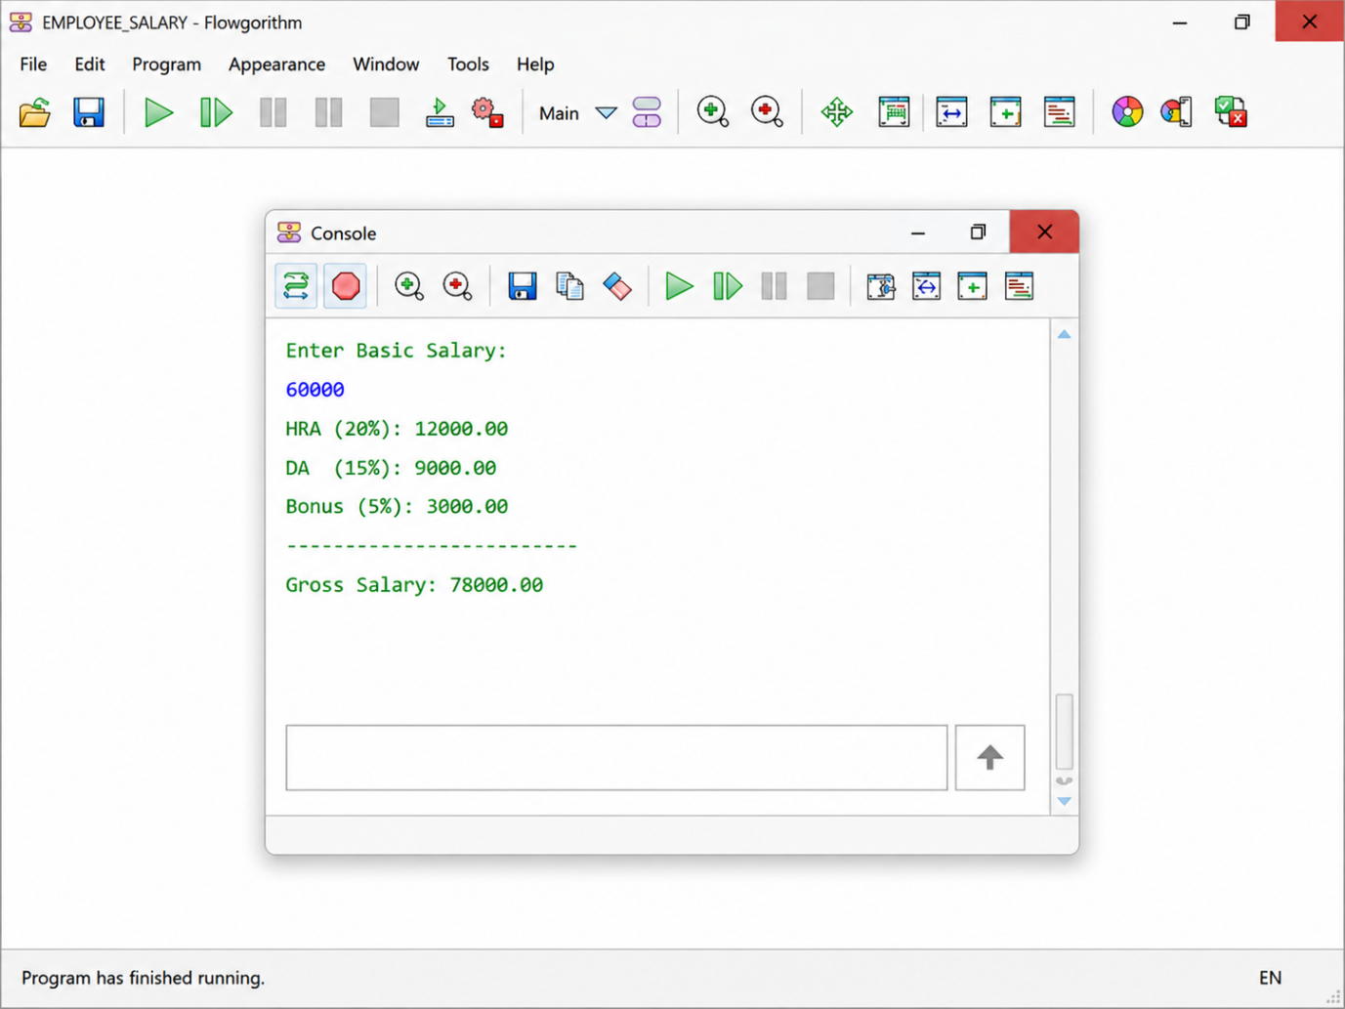
Pseudocode
BEGIN
DECLARE Basic, HRA, DA, Bonus, Gross AS REAL
INPUT Basic
HRA = Basic * 20 / 100
DA = Basic * 15 / 100
IF Basic > 50000 THEN
Bonus = Basic * 5 / 100
ELSE
Bonus = 0
END IF
Gross = Basic + HRA + DA + Bonus
OUTPUT "Basic Salary = ", Basic
OUTPUT "HRA = ", HRA
OUTPUT "DA = ", DA
OUTPUT "Bonus = ", Bonus
OUTPUT "Gross Salary = ", Gross
END
Java Program
import java.util.Scanner;
public class EmployeeSalary {
public static void main(String[] args) {
Scanner sc = new Scanner(System.in);

System.out.print("Enter Basic Salary: ");
double basicSalary = sc.nextDouble();

double hra = basicSalary * 0.20;
double da = basicSalary * 0.15;
double bonus = 0;
if (basicSalary > 50000) {
bonus = basicSalary * 0.05;
}

double grossSalary = basicSalary + hra + da + bonus; System.out.println("Basic Salary : " + basicSalary);
System.out.println("HRA : " + hra);
System.out.println("DA : " + da);
System.out.println("Bonus : " + bonus);
System.out.println("Gross Salary : " + grossSalary);
sc.close();
}
}
2.Read an integer N and display the first N terms of the Fibonacci sequence.
Flowchart:
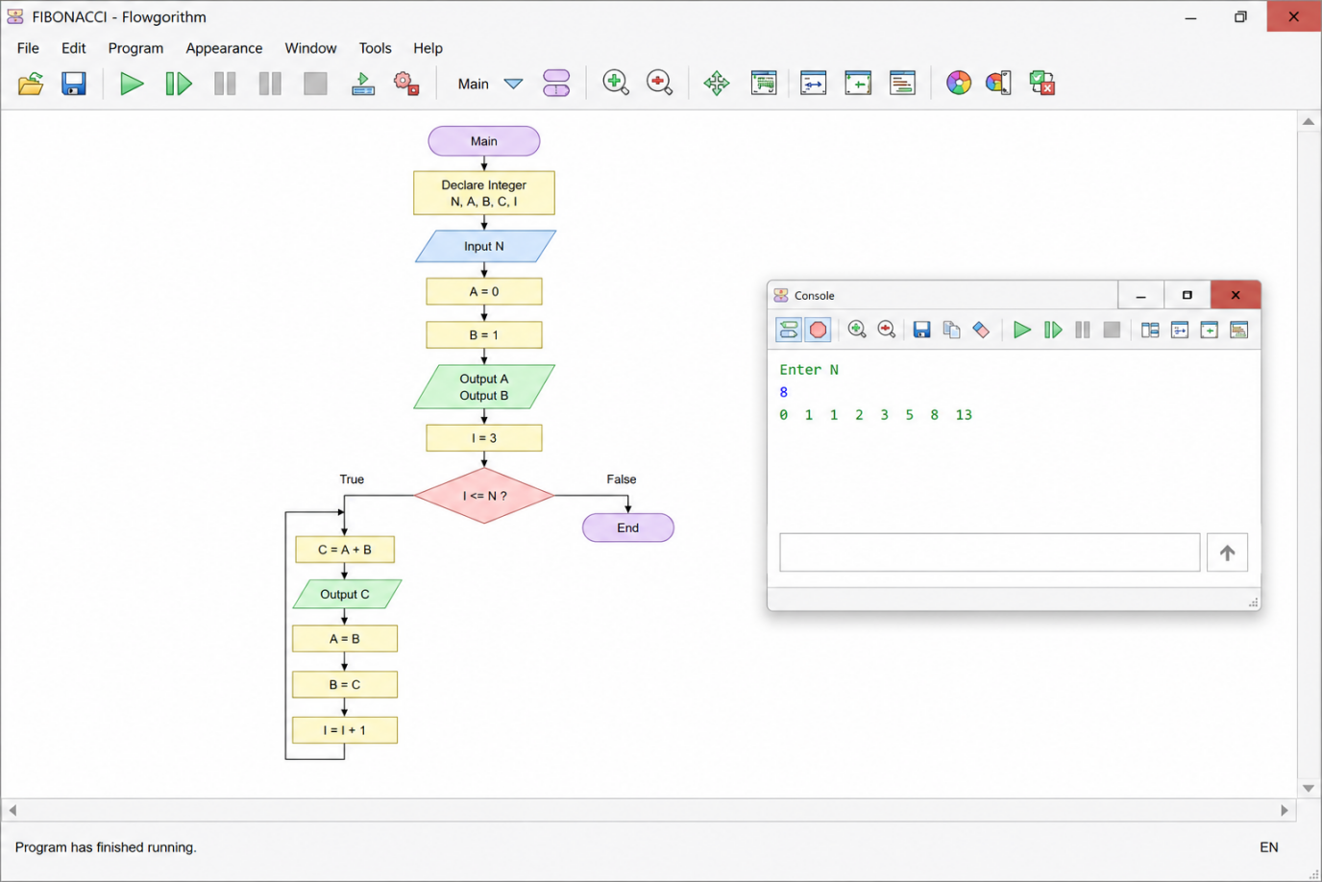

Pseudo Code
BEGIN
DECLARE N, A, B, C, I AS INTEGER
INPUT N
A ← 0
B ← 1
OUTPUT A
OUTPUT B
FOR I ← 3 TO N
C ← A + B
OUTPUT C
A ← B
B ← C
END FOR

END
Java Program
import java.util.Scanner;
public class Fibonacci {
public static void main(String[] args) {
Scanner sc = new Scanner(System.in);
int n, a = 0, b = 1, c;
System.out.print("Enter N: ");
n = sc.nextInt();
if (n >= 1)
System.out.print(a + " ");
if (n >= 2)
System.out.print(b + " ");
for (int i = 3; i <= n; i++) {
c = a + b;
System.out.print(c + " ");
a = b;
b = c;
}
}
}
3.Design a vehicle-rental flowchart that calculates charges differently for Car, Bike, and Van. Relate the common operation calculateRent to runtime polymorphism in Java
.
Flowchart:
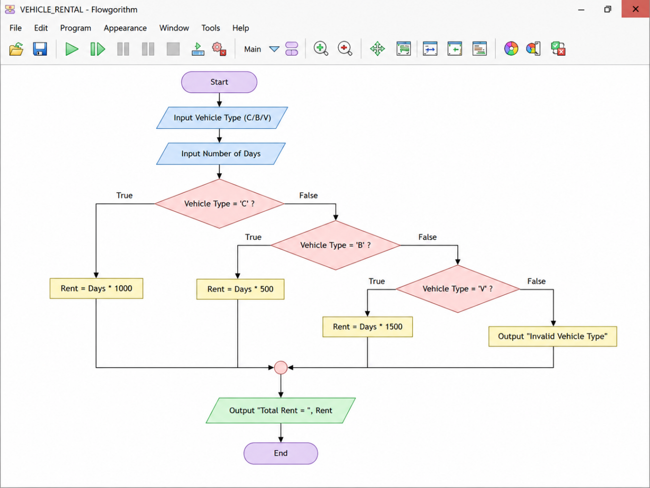
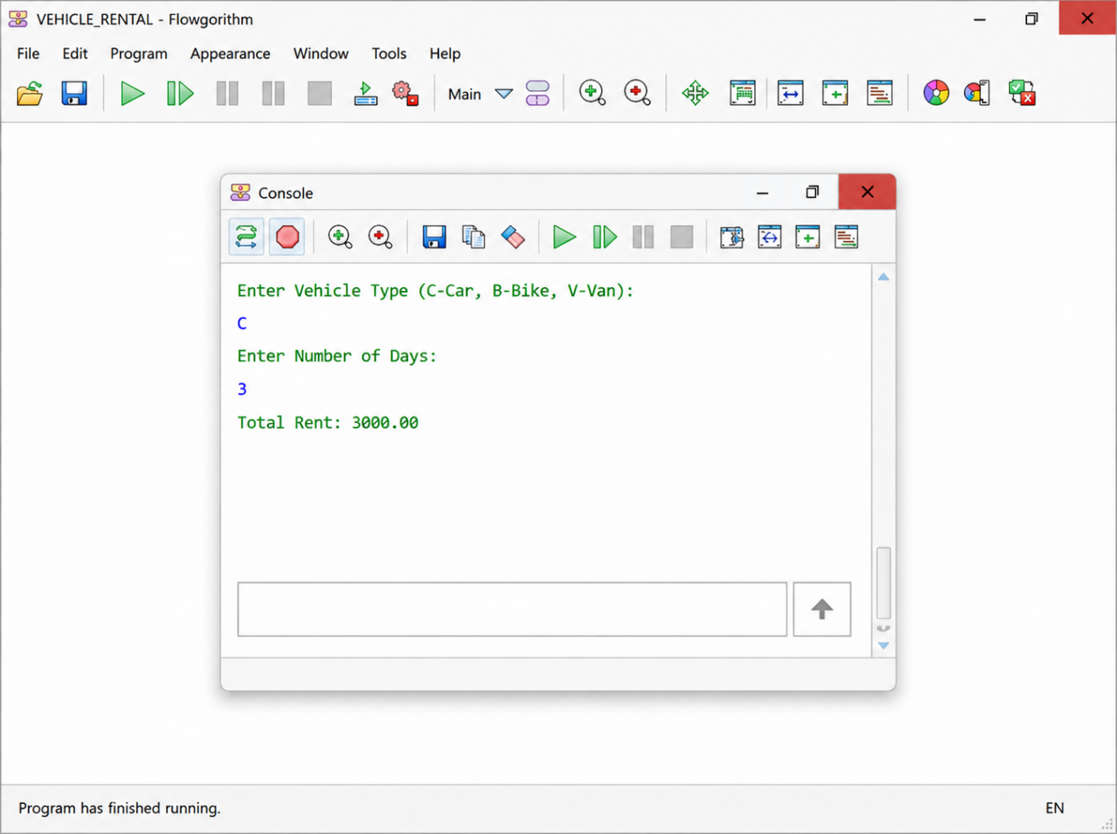

Pseudo Code
BEGIN
DECLARE VehicleType AS CHARACTER
DECLARE Days AS INTEGER
DECLARE Rent AS REAL
INPUT VehicleType
INPUT Days

IF VehicleType = 'C' THEN
Rent = Days * 1000

ELSE IF VehicleType = 'B' THEN
Rent = Days * 500

ELSE IF VehicleType = 'V' THEN
Rent = Days * 1500

ELSE
OUTPUT "Invalid Vehicle Type"
STOP
END IF
OUTPUT "Total Rent = ", Rent
END
Java Code
import java.util.Scanner;

class Vehicle {
double calculateRent(int days) {
return 0;
}
}

class Car extends Vehicle {
double calculateRent(int days) {
return days * 1000;
}
}

class Bike extends Vehicle {
double calculateRent(int days) {
return days * 500;
}
}

class Van extends Vehicle {
double calculateRent(int days) {
return days * 1500;
}
}

public class VehicleRental {
public static void main(String[] args) {
Scanner sc = new Scanner(System.in);

char type;
int days;
Vehicle vehicle;

System.out.print("Enter Vehicle Type (C/B/V): ");
type = sc.next().charAt(0);

System.out.print("Enter Number of Days: ");
days = sc.nextInt();

if (type == 'C' || type == 'c') {
vehicle = new Car();
} else if (type == 'B' || type == 'b') {
vehicle = new Bike();
} else if (type == 'V' || type == 'v') {
vehicle = new Van();
} else {
System.out.println("Invalid Vehicle Type");
return;
}

double rent = vehicle.calculateRent(days);

System.out.println("Total Rent = " + rent);
}
}

